ECE 395 – Optical guitar

Goal:
Build a guitar with lasers as the sensing mechanism
Parts used as yet:
- UA78M33CKC – 3.3 V 500 mA linear regulator
- LM78L05 – 5 V 100 mA linear regulator
- LM337T – (-3.3 V regulator) actually it is a adjustable negative voltage regulator.
- MC7905 – (-5V 100 mA regulator)
- Visible lasers: VLM-650001 LPT
- TDC GP21 chip
- Microcontroller: Renesas RX62N
- Photodiode: S5973 PIN photodiode

Edmund optics filter NT65-656 | 2
Edmund optics PCX lens NT65-499 | 2
TI OPA847ID | 4
TLV3502 | 2

Links
Laser Safety - http://ehs.uky.edu/radiation/laser_fs.html
Senior Design Guide to photodiodes - http://courses.engr.illinois.edu/ece445/wiki/?n=Topics.LaserDiodeAndPhotodiodeIntroduction

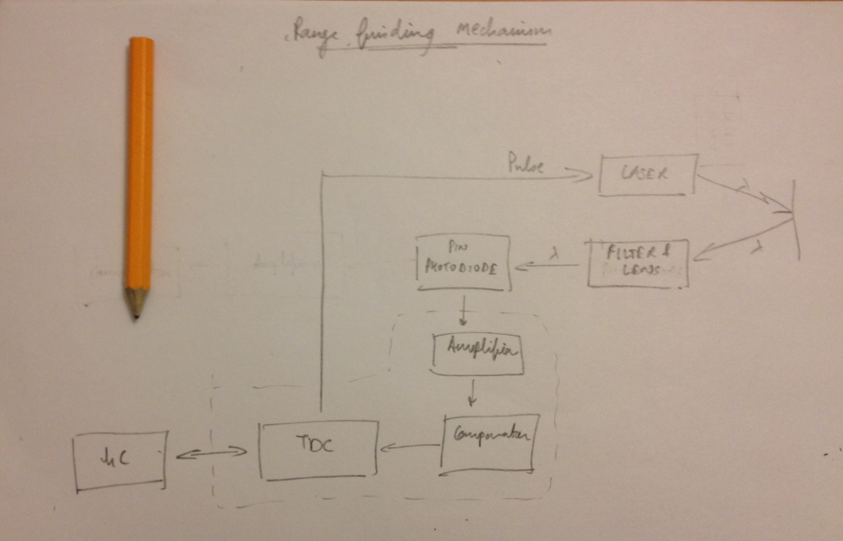
Current Status
- The filter and lens combination with photodiode and encapsulation has been built. The ambient noise is reduced to fraction of the intensity of the signal
- Trans impedance amp and non inverting amp stages built but are not working right
- Possible issues include - the component values not being correct and can be tested using the RLC meters in Power Lab
- Now what - Test the trans impedance stage first and then proceed to next one.
- Once that is done, we can work on the comparator stage ( we need the triggering values to know the component values)
- Another thing that can be done is that the TDC chip can be initialized
- Make the components list for this chip and make sure you have them before the weekend.
- Another benefit would be using the fire pulse unit
- Another thing that has to be done is figuring out the SPI control on the Renesas (but that can be done over the weekend).
- Take a look at the power requirements for the linear regulators and use input and output capacitors

Additional info:

Laser APC circuits
Drive circuits for laser diodes are either automatic power control (APC) circuits that maintain a constant light output power or automatic current control (ACC) circuits that maintain a constant current. The output power and wavelength of the laser diode can be affected by the changing of temperature. APC circuits provide a constant light output power despite variations in ambient temperature. If you have a DC power supply which provides you an accurate and stable DC voltage. You may use this APC circuit board without voltage regulator. APC with voltage regulator circuit enhances the function of APC circuit. It provides constant output power when the input voltage is between 2.8V DC and 6V DC.

Ideas –
- the idea of LIDAR
- camera triangulation
- sensors on hand and pick

